CN Lab 1:
24k-0810
TASK 1: Identify the class of the following IP addresses:
1. 192.0.2.15: Class C
2. 11.1.1.1: Class A
3. 239.255.255.250: Class D
4. 172.31.255.1: Class B
5. 169.254.1.1: Class B
TASK 2: Determine whether the following IPv4 addresses are valid for a host configuration on a local area network. If invalid, briefly state why:
1. 192.168.1.256: Invalid. An IPv4 octet can only range from 0 to 255.
2. 127.0.0.1: Invalid. Network 127 Is reserved for loopback and internal testing.
3. 200.100.50.0/24 (as a host address): Invalid. 0 can’t be normally assigned to a host with /24 mask.
4. 8.8.8.8: Valid
5. 10.0.0.-5: Invalid. -5 is not a valid IPv4 octet. An IPv4 octet can only range from 0 to 255.
TASK 3: Find the physical (MAC) address of the primary network interface on your current
computer.
Command used: ipconfig /all
MAC Address: 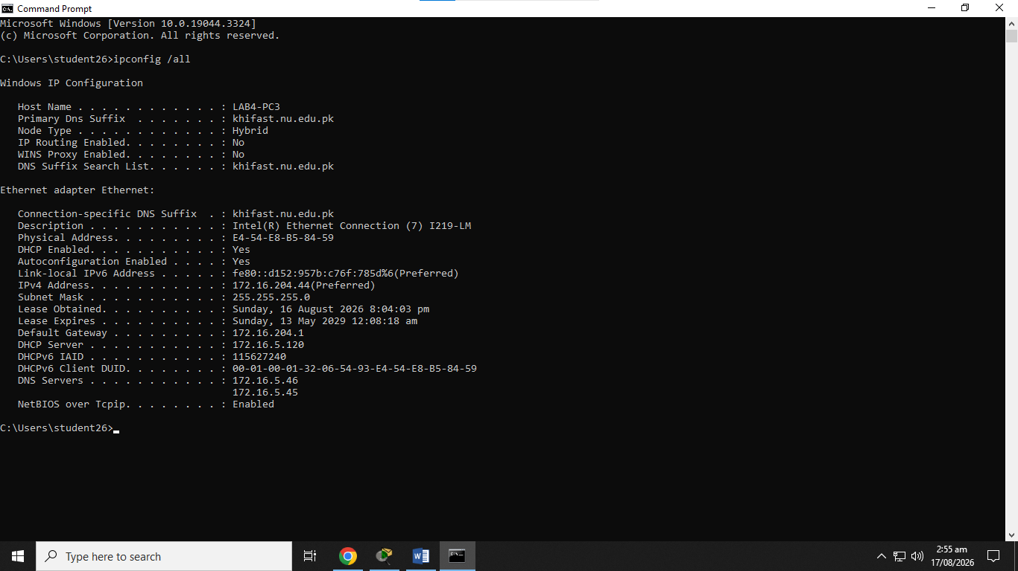
TASK 4: Can you connect a PC directly to another PC or a Switch to a Router using a Straight through cable without Auto-MDIX enabled? Explain your answer for both scenarios.
- PC directly connected to another PC
A PC has an MDI interface. Two PCs connected directly together have the same interface type. Therefore, straight through cable cannot be used and a crossover cable is required when Auto-MDIX is not available.
- Switch to Router
A traditional switch port operates as MDI-X, while a traditional router Ethernet port operates as MDI. Because they are different interface types, thus, we can use a straight-through cable.
TASK 5: Which physical medium and connection standard would you choose to connect two network switches located in different buildings 500 meters apart? Explain your choice over standard Twisted-Pair copper cables.
I would choose Fiber optic cable because typical copper Ethernet runs are limited to approximately 100 meters per segment. A 500-meter connection therefore exceeds the normal distance limitation of standard copper Ethernet.
TASK 6: You can ping an external IP address (such as 8.8.8.8), but attempting to ping
google.com yields a “Destination host unreachable” or “Could not find host” error. What is the most likely cause, and how would you resolve it?
This is a DNS problem. If the computer can successfully ping 8.8.8.8, basic IP connectivity to the internet is working. However, when the user enters google.com, the computer must translate the domain name into an IP address using DNS.
I will check the DNS settings or try using a public DNS server such as Google's DNS (8.8.8.8 and 8.8.4.4) or another trusted DNS service.
TASK 7: A user’s computer has an IP address of 192.168.1.50 with a subnet mask of
255.255.255.0. The default gateway is set to 10.0.0.1. Can this user access the internet?
Explain why or why not.
No, the computer will normally not be able to access the internet using this configuration.
The computer belongs to the network 192.168.1.0/24. Its default gateway, however, is 10.0.0.1, which belongs to the 10.0.0.0/24 network. The computer cannot directly reach 10.0.0.1 because the gateway is outside its local subnet. A default gateway should normally be on the same local subnet as the host.
A suitable gateway would be something such as 192.168.1.1.
TASK 8: Categorize each of the following IP addresses as either Public or Private:
1. 10.50.100.1: Private
2. 172.20.10.4: Private
3. 8.8.4.4: Public
4. 192.168.100.254: Private
5. 198.51.100.10: Public
TASK 9: Identify the default network protocol associated with each of the following well-known port numbers:
1. Port 80: HTTP
2. Port 443: HTTPS
3. Port 22: SSH
4. Port 53: DNS
5. Port 21: FTP
TASK 10: Draw or insert a diagram of a standard home network connected to an ISP modem.
1. Identify the topology type used. Star topology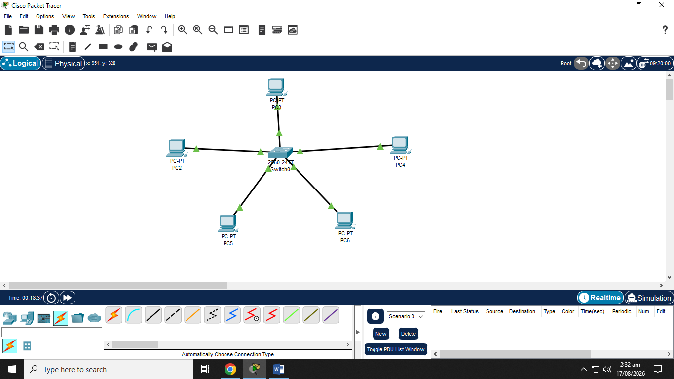
2. Label all device types (e.g Modem, Router, Switch, Wireless Access Point, End
Devices).
Switch: cisco 2690, end devices: PC2, PC3, PC4, PC5, PC6, Ethernet cable connecting all devices.
3. Provide a brief write-up (1 page max) explaining how data flows from an end-user device out to the internet.
When an end-user device, such as a PC, wants to access another PC, it first connects to the switch through Ethernet. The device has a private IP address, such as 10.10.10.10. The PC sends the data to the switch. The switch checks the destination IP address and forwards it to the appropriate PC without sending the data to other PC. This makes the star topology simpler to manage.

